Static Route

🧱 What Is Static Route?
# Source: Chatgpt (GPT‑5 Mini) at [12/14/2025]
A static route is a manually configured path in a device's routing table. Unlike dynamic routes, it does not change automatically and must be added, modified, or removed by a network administrator.

🧠 Simple Definition:
# Source: Chatgpt (GPT‑5 Mini) at [12/14/2025]
A static route tells the router:
“To reach this destination network, send packets via this specific next-hop IP or interface — and don’t learn it from routing protocols.”

🧾 Example:
# Source: Chatgpt (GPT‑5 Mini) at [12/14/2025]
You want to route traffic to network 10.10.20.0/24 through a next-hop router at 192.168.1.2.
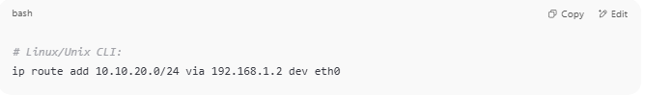
# Linux/Unix CLI:
ip route add 10.10.20.0/24 via 192.168.1.2 dev eth0

Routing Table Entry:
# Source: Chatgpt (GPT‑5 Mini) at [12/14/2025]

Destination | Netmask | Next Hop | Interface
10.10.20.0 | 255.255.255.0 | 192.168.1.2 | eth0

🔍 Characteristics of Static Routes:
# Source: Chatgpt (GPT‑5 Mini) at [12/14/2025]
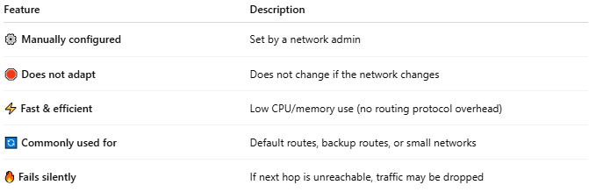
Feature | Description
⚙️ Manually configured | Set by a network admin
🛑 Does not adapt | Does not change if the network changes
⚡ Fast & efficient | Low CPU/memory use (no routing protocol overhead)
🔄 Commonly used for | Default routes, backup routes, or small networks
🔥 Fails silently | If next hop is unreachable, traffic may be dropped

🖥 Example on Cisco Router:
# Source: Chatgpt (GPT‑5 Mini) at [12/14/2025]
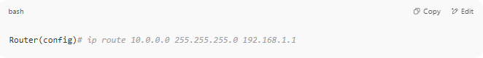
Router(config)# ip route 10.0.0.0 255.255.255.0 192.168.1.1

This tells the router: "To reach 10.0.0.0/24, send packets to 192.168.1.1."

✅ Summary
# Source: Chatgpt (GPT‑5 Mini) at [12/14/2025]
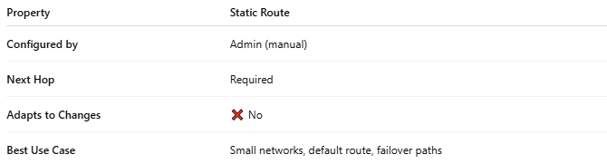
Property | Static Route
Configured by | Admin (manual)
Next Hop | Required
Adapts to Changes | ❌ No
Best Use Case | Small networks, default route, failover paths

